AS 1684 RESIDENTIAL TIMBER FRAMING CONSTRUCTION (AS 1684.2)

1.1 Scope
AS 1684 specifies requirements for building practice and the selection, placement and fixing of the various structural elements used in the construction of timber-framed Class 1 and Class 10 Buildings as defined by the Building Code of Australia and within the limitations given in Clause 1.6.

Building classes
Class 1(a) Detached house
Attached dwellings
(Terrace houses, Villas etc.)

Class 1(b) Boarding house
• not more than 300 sq. mtrs
• not more than 12 residents

Class 10 Outbuildings
(garages, carports etc.)

USE OF ALTERNATIVE MATERIALS OR METHODS
This Standard does not preclude the use of framing or fastening methods or materials other than those specified. Alternatives may be used, provided they satisfy the requirements of the Building Code of Australia.

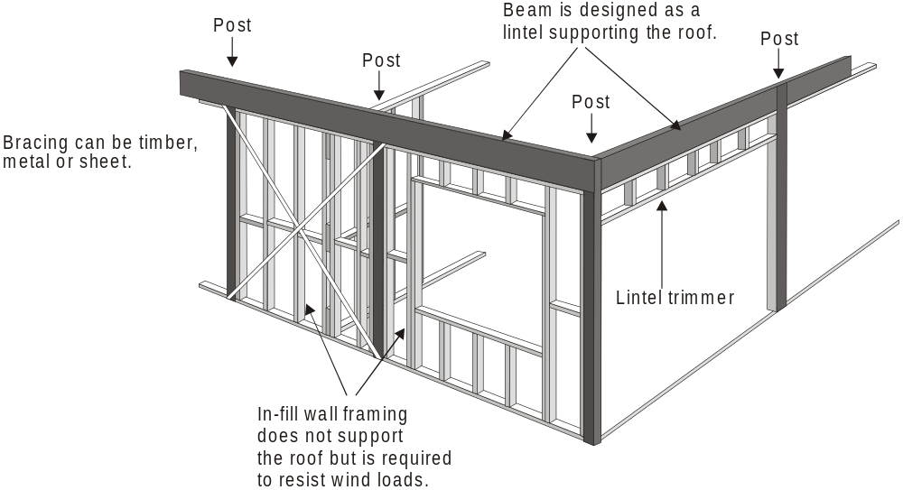
Figure 1 Conventional Frame

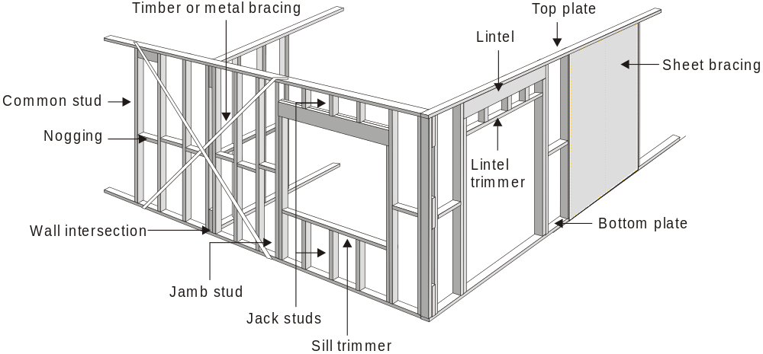
Figure 2 Post and Beam Structure

Wind Classification
Either AS 4055 – Wind Loads for Housing (the simplified wind classification standard) or AS 1170.2 SAA Loading code Part 2 – Wind loads shall be used to determine the wind classification necessary for the use of this Standard.

Where the wind classification is determined from AS 4055, the maximum building height limitation of 8.5m given in AS 4055 shall apply to this Standard.

(The height limitation of 8.5 m to the ridge applies when using AS 4055 because this height is used by AS 4055 to determine the appropriate wind classification.)

Wind classification (non-cyclonic)

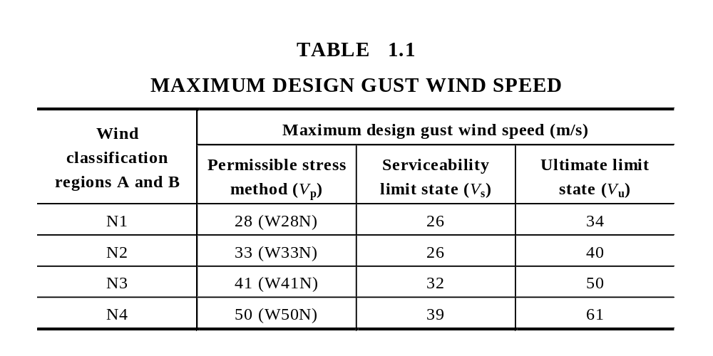

Wall height
The maximum wall height shall be 3000 mm (floor to ceiling) as measured at common external walls, i.e. not gable or skillion ends.

Roof Pitch
The maximum roof pitch shall be 35° (70:100).

Roof types
Roof construction shall be hip, gable, skillion, cathedral, trussed or pitched or in any combination of these.

Building Masses
For rafters or purlins, the ‘supported materials’ will include the weight of the roofing material, roof battens, sarking and/or insulation plus ceiling battens and ceiling sheeting for a cathedral roof.
The mass of a member being considered has been accounted for in the design of that member.

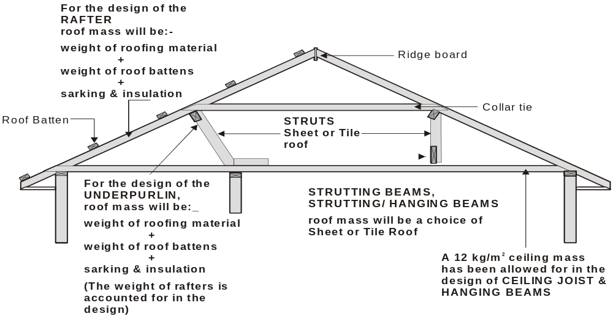

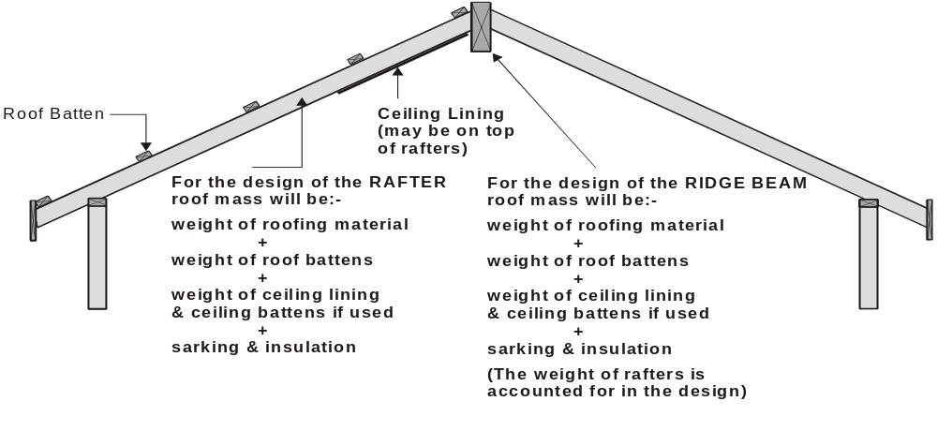

DESIGN CRITERIA

The basis of the design used in the preparation of this Standard is AS 1684.1 and AS 1720.1.
The design dead, live, and wind loadings recommended in AS 1170.1, AS 1170.2 and AS 4055, were taken into account in the member computations, with appropriate allowances for the distribution of concentrated or localized loads over a number of members where relevant.

FORCES ON BUILDINGS

The design of framing members may be influenced by the wind forces that act on the specific members. When using Span Tables in the Supplements, the appropriate wind classification (e.g. N2) together with the stress grade shall be established prior to selecting the appropriate supplement to obtain timber member sizes.

The main forces acting on buildings are:

Dead Loads the forces arising from the weight of the building components themselves.
Live Loads the forces arising from the weight of persons using the building and moveable furniture.
Wind Loads the forces arising from - gales, thunderstorms & tropical cyclones.

GUIDELINES FOR DESIGN USING THIS STANDARD

Bracing and tie-down requirements should also be considered when determining the basic frame layout to ensure any necessary or additional framing members are correctly positioned.

